UCD School of Electrical, Electronic and Communications Engineering

EEEN20090 Electrical Energy Systems II

# Power System Simulation - Part 2

**Author:** Fergal Lonergan **Student Number:**  13456938

**Working with:** Ruairi O’Donoghue **Student Number:** 13456968

### Declaration

I declare that the work described in this report was done by the people named above, and that the description and comments in this report are my own work, except where otherwise acknowledged. I have read and understand the consequences of plagiarism as discussed in the EECE School Policy on Plagiarism, the UCD Plagiarism Policy and the UCD Briefing Document on Academic Integrity and Plagiarism. I also understand the definition of plagiarism.

Signed: Fergal Lonergan Date: 11/3/15

1.1 Load Flow

Perform a load flow simulation and determine the following:

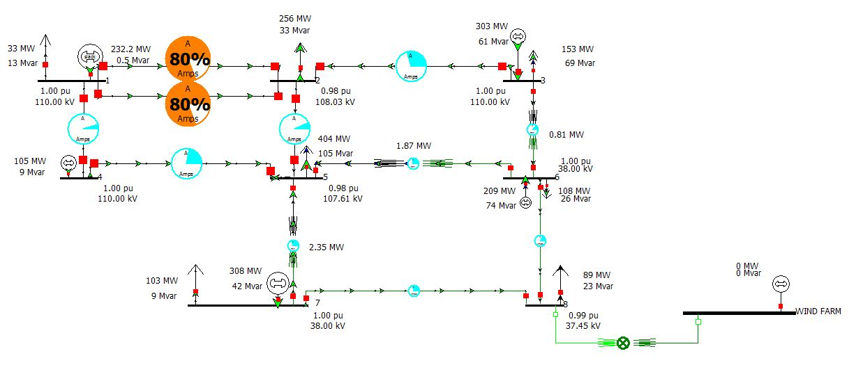

Task 1: What is the real and reactive power provided by (slack bus) G1 to ensure that the load is matched by generation?   
Real Power = 232.2 MW  
Reactive power = 0.5 MVAR

Task 2: What is the power loss across transformers T1, T2 and T3?  
Transformer 1 = 0.81 MW  
Transformer 2 = 2.35 MW  
Transformer 3 = 1.87 MW

Task 3: What is the voltage at bus 2 & bus 8 in pu and kV?   
Bus 2 Voltage equals 0.98pu and 108.03kV.  
Bus 8 Voltage equals 0.99pu 37.45kV

Task 4: If the parameters of G7 are adjusted so that it now provides zero reactive power, what impact does this have on the voltage at bus 7?   
All the voltages at every bus including 7 drop.

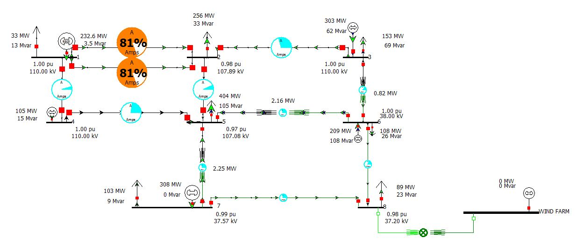

Reset the parameters of G7 to their initial values once the impact of the adjustment has been verified?

Task 5: How would the voltages at the non-generating buses (2, 5 & 8) be maintained at 1 pu?   
Ideally if you add a generator to all the non-generating buses that will solve the problem and force the voltages to be maintained at 1 pu. Alternatively if you add a capacitor at each due to the fact that they are below 1pu and we need to add power (use an inductor if it was above 1 to reduce it) A very unrealistic approach would be to change the transmission lines however this would be incredibly expensive. Also you can manipulate the generating buses so that there pu was higher and so the values at the non-generating buses increase accordingly, if you felt that these three buses were of significant importance.

1.2 Power System Economics

Power system operators must ensure that there is sufficient generation online at all times to match the demand (load) on the system, and must do so in the most economical way possible. Different generators will have different operating costs, determined by the type of fuel used, capacity, etc. Table 5 shows the cost characteristics for the generating units in the assignment. PMAX and PMIN for each unit are as given in Table 1.

No-load costs are incurred every hour while the unit is on load and are independent of the amount of power being supplied to the grid. The hourly cost (€/h) of a generating unit is the product of the generator’s actual output, PGEN, and the incremental fuel cost, and combined with the no-load costs.

Task 6: If generator G4 must always be on (i.e. must always run at least at PMIN), use the unit limits from Table 1 and a decision tree approach to determine the cheapest generation schedule that will meet the system load defined in Table 2 for 1 hour.

• Draw a decision tree.

• Determine the minimum operating cost, if feasible, for each combination of units.

• Prune the decision tree if an infeasible combination of units is found.

• Determine the cheapest combination of units and economic dispatch to meet the demand.

The first digit is G1, the second G3, the third G4, the fourth G6 and the fifth G7.

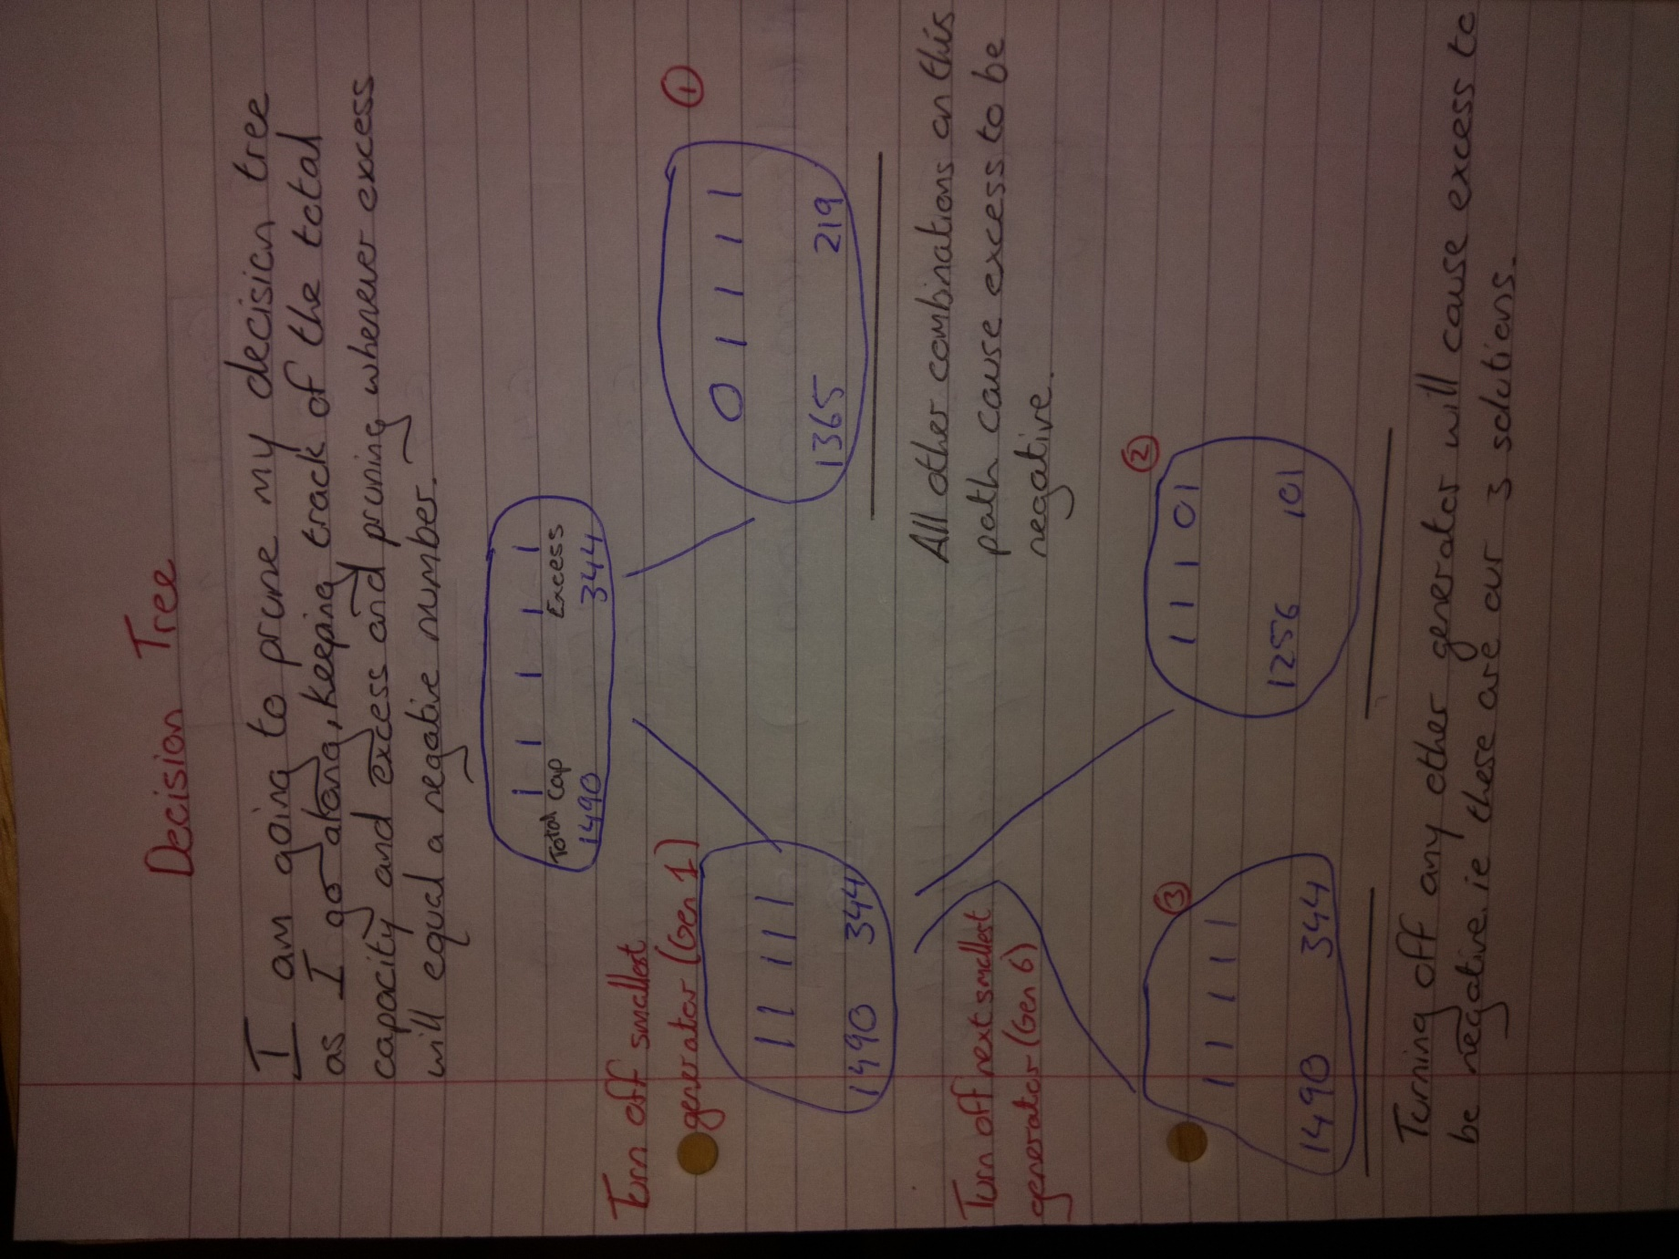

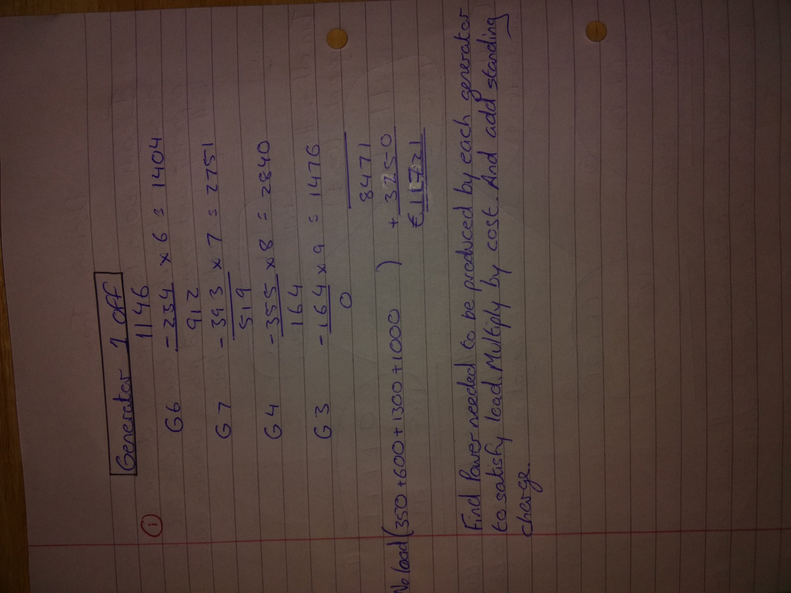

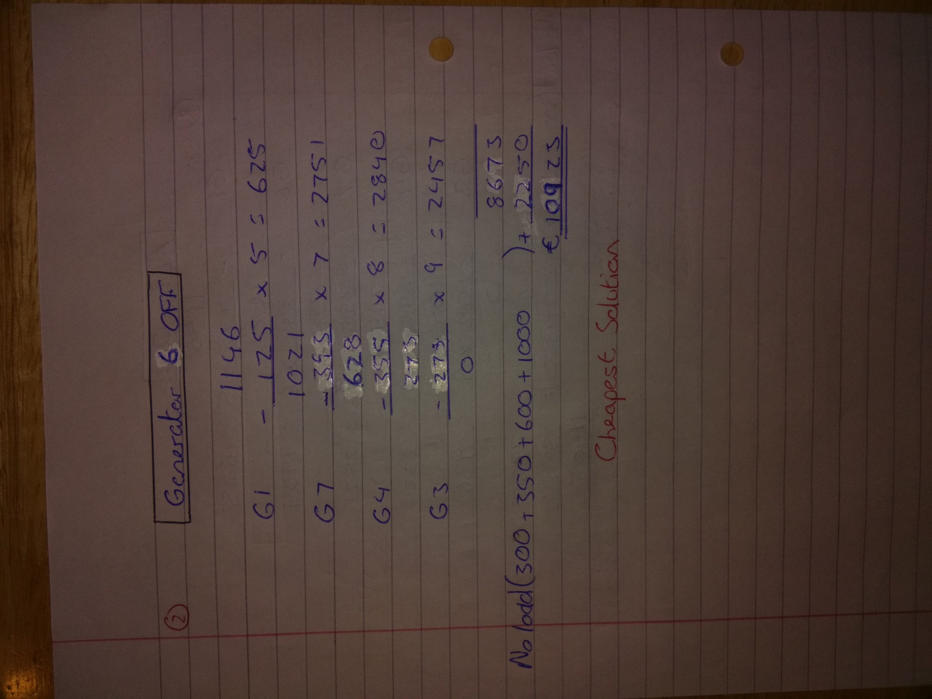

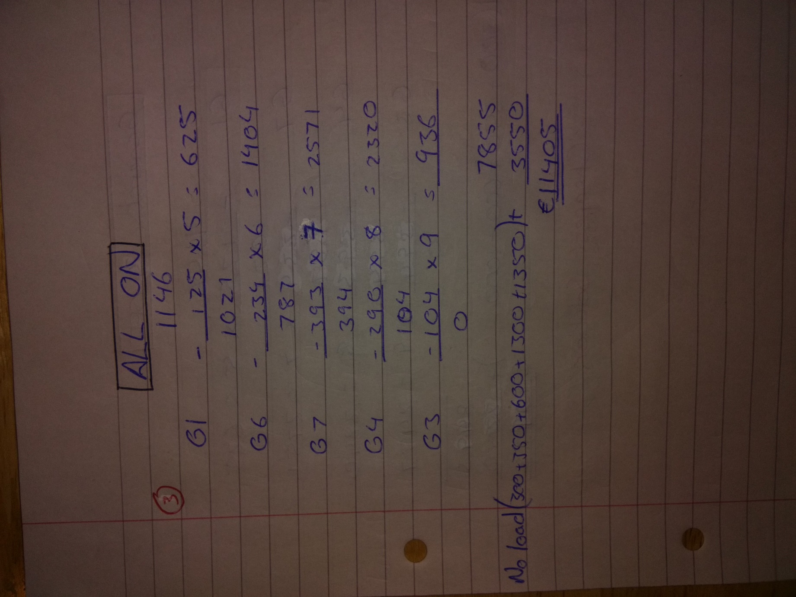

Task 7: Implement the optimal solution of Task 6 on the 8-bus power system, and comment on the results obtained.   
If we use the minimum solution found by working out our decision tree our power lines between bus 1 and 2 are at 93% also there are losses in the system so we would have to increase our generators to compensate. This system has all generators at their max except for G3.

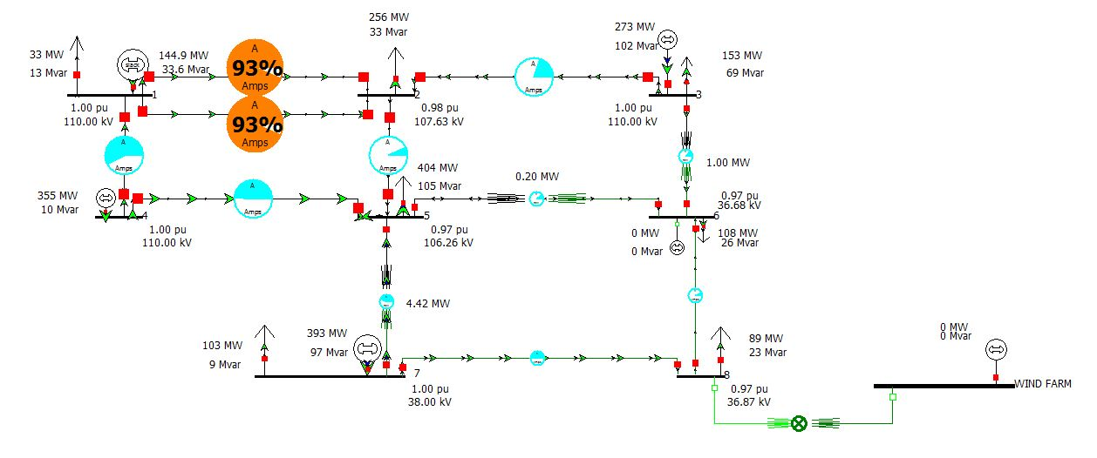

Task 8: If G4 suddenly failed discuss the problems that would result. How could you dispatch the system to mitigate for such occurrences?   
If we implement our ideal solution and generator 6 is off and all other generators are at their max except G3 the transmission lines between Bus A and Bus B would overload considerably. (141%) if you put g3 to max while g1 is still your slack the lines are still overloading yet a good bit less. (105%) pics ….. also if you disconnect bus2 and bus5 this causes more current to go through the line from 1 to 4 which reduces the load on 1 to 2.

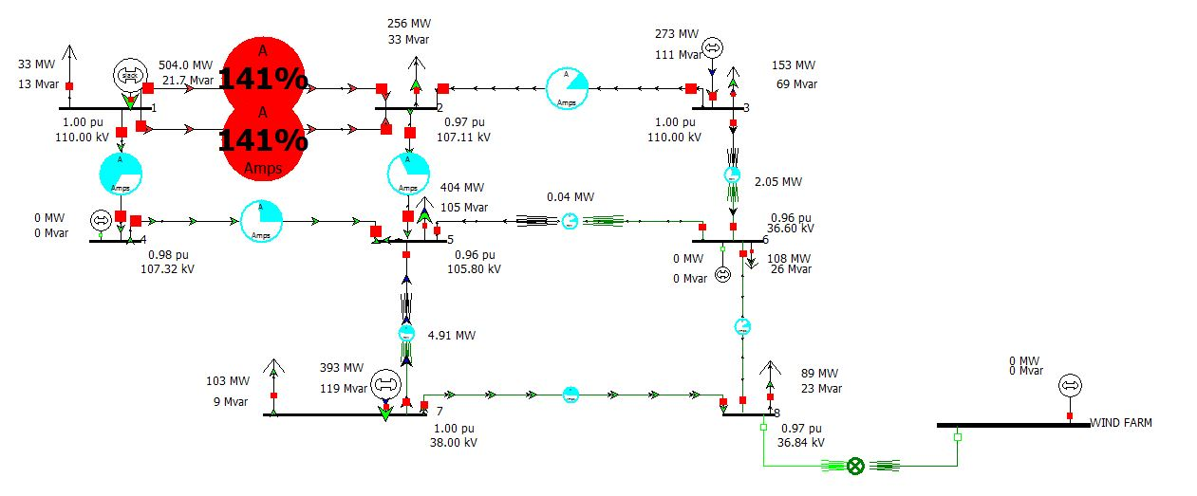

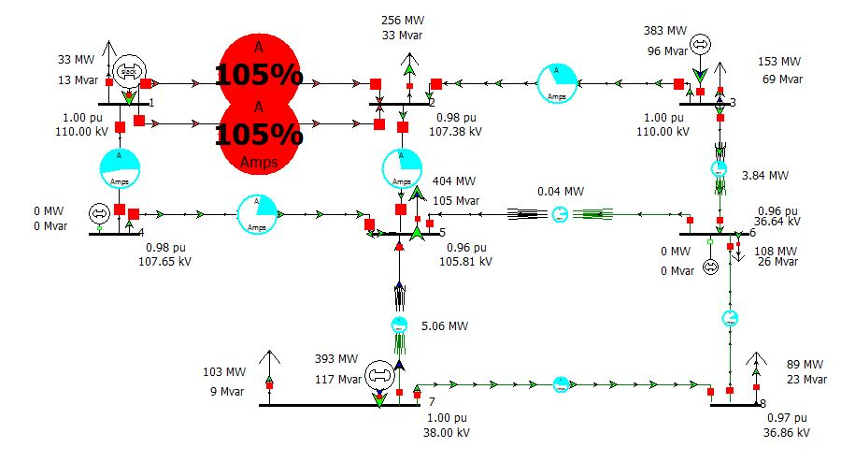

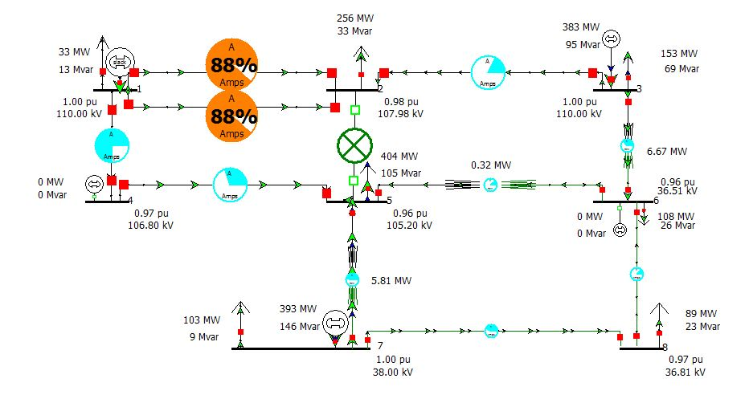

1.3 Introducing Wind Power into the Network

A wind farm is now connected to the system, which can be represented by a single generating unit with the following characteristics: active power, PMAX = 200 MW, and operating at 0.95 “constant power factor” wind control mode. The wind farm bus is assumed to be operating at maximum output in our simulation. The wind farm bus nominal voltage is 690 V and is connected to Bus 8 via a 250 MVA transformer, the parameters of which are otherwise the same as T3.

Task 9: Outline 2 advantages and 2 disadvantages of connecting wind farms to the system.  
ADVANTAGES:  
1. No need to pay for fuel.   
2. Reduces the load on the heavily loaded lines between bus 1 and 2.

DISADVANTAGES:   
1. It reduces the pu at bus 5 to .97 from .98.   
2. The power generated isn’t constant or controllable it completely depends on the weather this means sometimes we are generating more power than we need to as we can’t rely on the windfarm’s input.

Task 10: How will introducing the wind farm affect the optimal unit commitment for the system?  
Introducing the wind farm will reduce the optimal unit commitment of the system.

Task 11: Why are wind farms usually connected at the distribution voltage level?  
When connecting large wind farms to the power grid, these will typically be connected far away from the large generators in the system that provides for grid stability and base power production. Issues such as voltage control, grid stability during and after faults and frequency regulation are areas where the new SVC Light Energy Storage system will support the wind farm, and the combined function will to a large extent be similar to that of a large generator.

Perform a load flow simulation for the expanded system, based on the generator dispatch from Task 6 and determine:

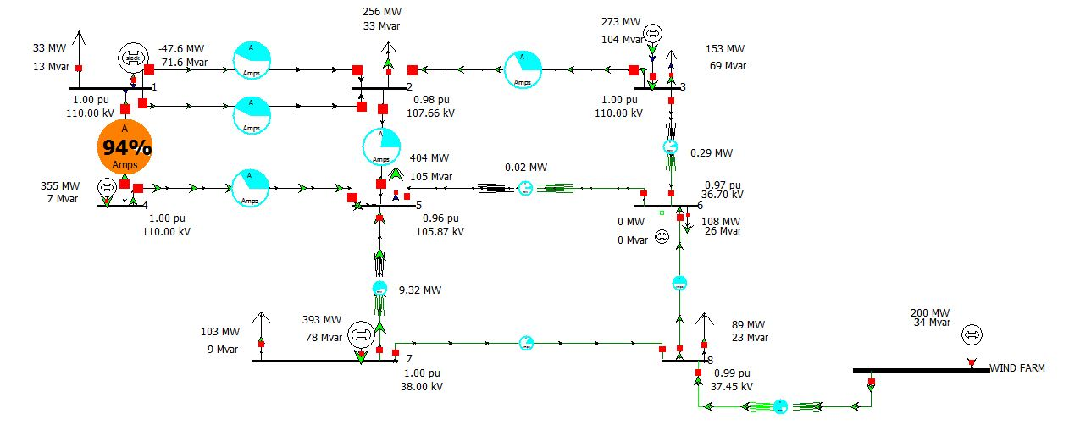

Task 12: The real and reactive power provided by G1 to ensure that the load is matched by generation.   
The real power provided by G1 is -47.589 MW   
The reactive power provided by G1 71.596 MVAR

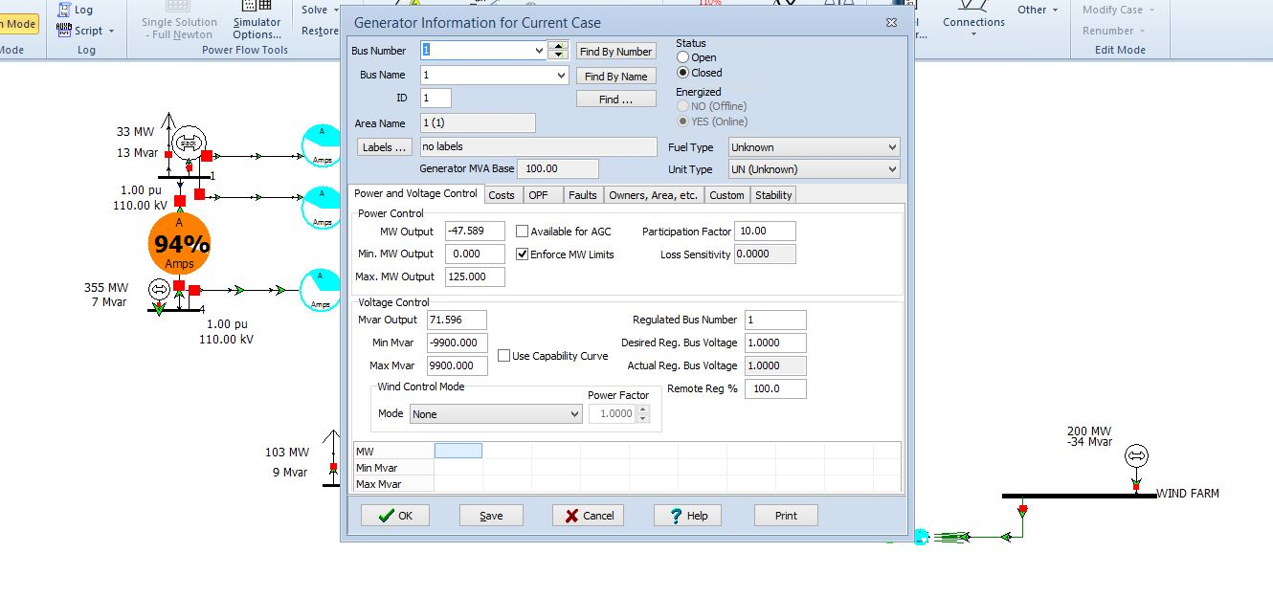

Task 13: The reactive power output of the wind farm. Is the wind farm generating or absorbing reactive power?   
The reactive output is -33.732 MVAR so the wind farm is absorbing reactive power.

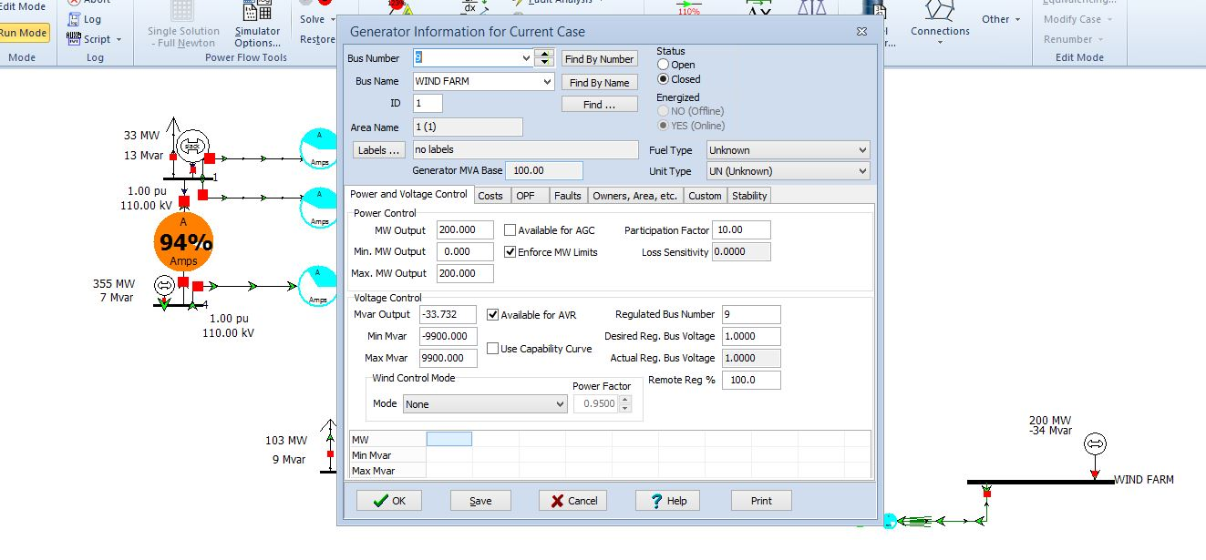

Task 14: Comment on the load flow results obtained.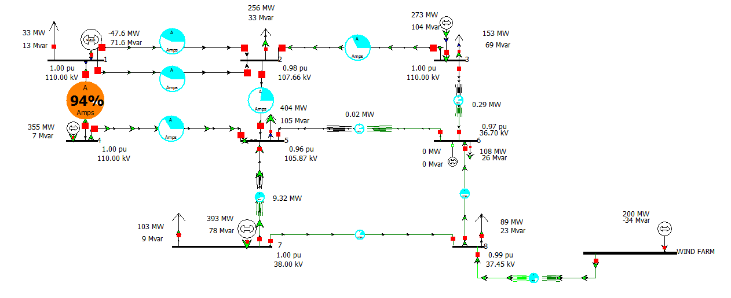We see that the transmission lines between bus4 and bus 1 are very heavily loaded. Also the transformer between bus7 and bus5, and the wind farm and bus 8, are quite heavily loaded too. All other transmission lines and transformers are fine with the load on the lines entering and leaving bus 6 carrying very little load.